Smithsonian Leadership Retreat

Thursday, May 22, 2025

Venue Locations

Breakfast, Lunch | National Cathedral Towers (7th floor) | Washington National Cathedral  3101 Wisconsin Ave NW, Washington, DC 20016
Auditorium | Charles A. Perry Auditorium | Washington National Cathedral  3101 Wisconsin Ave NW, Washington, DC 20016
Cocktail Reception | National Cathedral Nave | Washington National Cathedral  3101 Wisconsin Ave NW, Washington, DC 20016

Run of Show

ARRIVAL INSTRUCTIONS
EVENT STAFF:
Parking in National Cathedral Garage, Enter via Wisconsin Avenue, at the traffic signal just south of Woodley Road

SMITHSONIAN LEADERSHIP STAFF:
Arrives via Smithsonian shuttle, drop-off at entrance and park in reserved spot in the National Cathedral 18 spot bus garage (or individual parking as needed)

VIPS/DONORS:
Parking in National Cathedral Garage, Enter via Wisconsin Avenue, at the traffic signal just south of Woodley Road

All Staff
Event Agency
Vendor(s)
Smithsonian Staff
VIPS/Donors

DATE | TIME | DESCRIPTION | RESPONSIBLE
Wed, May 21 | 8:00pm | Dropoff for catering equipment | Well Dunn Catering Staff (Diana Meadows)
 | 8:30pm | Load-in for lighting equipment | 4 Wall Staff (Ann McDaniel)
Thur, May 22 | 5:45am | Event agency staff arrives | Event Agency
 | 6:00am | Load-in begins
 | 6:15am | Set up tables in cathedral towers | Event Agency
 | 6:45am | Décor staff arrives and begins setup (Décor for the reception will be loaded in but left in the Nave) | Le Chateau de Crystale Events (Monique Goodwin)
 | 7:00am | Catering staff arrives | Well Dunn Catering Staff (Diana Meadows)
 | 7:00am | Set up podium and check in table | Event Agency
 | 7:30am | Photographer from Smithsonian Enterprises arrives | Smithsonian Enterprises (David Greer)
 | 8:00am | Staff check-in/briefing meeting
 | 8:30am | Breakfast is set out by catering – Well Dunn breakfast menu 1 | Well Dunn Catering Staff (Diana Meadows)
 | 8:45am | Smithsonian leadership/staff arrive | Event Agency - Bonnie Campbell
 | 8:45am | Smithsonian staff check-in begins (staff direct them up to Cathedral towers) | Event Agency
 | 8:50am | Doors open for breakfast
 | 9:00am | Smithsonian staff breakfast begins | Well Dunn Catering Staff (Diana Meadows)
 | 9:55am | Smithsonian staff transitions to Charles A. Perry auditorium | Event Agency - Bonnie Campbell
 | 10:00am | Meeting on budget, marketing and promotion for new exhibits begins (Charles A. Perry auditorium) | Katie Desmond
 | 10:00am | Catering staff cleans up from breakfast | Well Dunn Catering Staff (Diana Meadows)
 | 10:10am | Remarks on budget from Ronald Cortez - Under Secretary for Finance and Administration | Showcall/MHA (Mary Larsen)
 | 11:00am | Show video on new marketing campaign | Showcall/MHA (Mary Larsen)
 | 11:00am | Catering transition from breakfast to lunch setup in Cathedral towers | Well Dunn Catering Staff
DATE | TIME | DESCRIPTION | RESPONSIBLE
 | 11:15am | Remarks on marketing and promotion from Julissa Marenco -Assistant secretary for communications and external affairs and chief marketing officer | Showcall/MHA (Mary Larsen)
 | 11:45am | Catering staff sets out food – Well Dunn lunch menu 2 | Well Dunn Catering Staff (Diana Meadows)
 | 12:00pm | Move back to cathedral towers for lunch
 | 12:55 pm | Smithsonian staff transitions to Charles A. Perry auditorium | Event Agency - Bonnie Campbell
 | 1:00pm | Wrap up from CEO Lonnie G Bunch III | Showcall/MHA (Mary Larsen)
 | 1:20pm | Remarks from Nicole Angarella, Inspector General | Showcall/MHA (Mary Larsen)
 | 1:35pm | Group photo (auditorium stage) | Smithsonian Enterprises
 | 1:45pm | Greg Bettwy- closing remarks (invite Smithsonian staff to optional Cathedral tour) | Showcall/MHA (Mary Larsen)
 | 2:00pm | Optional tour of Cathedral Grounds | Aneisha Prasad
 | 2:00pm | DJ arrives with equipment | District DJ (David Greer)
 | 2:00pm | Décor setup in the Nave begins | Le Chateau de Crystale Events (Monique Goodwin)
 | 2:00pm | Catering staff transitions to Nave | Well Dunn Catering Staff (Diana Meadows)
 | 2:00pm | AV setup for presentations begin in the Nave (move any equipment needed from 7th floor, setup any equipment still stored in Nave) | Showcall/MHA (Mary Larsen)
 | 2:05pm | Additional catering staff for reception arrive to assist with preparation and setup (tables, bar, etc.) | Well Dunn Catering Staff (Diana Meadows)
 | 2:10pm | Food for reception delivered by catering via refrigerated truck | Well Dunn Catering Staff (Diana Meadows)
 | 2:15pm | A/V assists/collaborates with DJ to finalize setup by the main stage | District DJ  Showcall/MHA
 | 2:30pm | Lighting tests or finishing touches for lighting setup | 4 Wall Staff (Ann McDaniel)
 | 3:00pm | Break begins for Smithsonian staff
 | 3:15pm | Greenroom opens for Smithsonian leadership to prepare for the reception | Event Agency - Bonnie Campbell
 | 3:30pm | Raffle and giveaway items delivered by agency staff to the Nave | Event Agency
DATE | TIME | DESCRIPTION | RESPONSIBLE
 | 4:30pm | Greenroom access transitions from Smithsonian leadership to VIPs | Event Agency - Bonnie Campbell
 | 4:30pm | Nave reception setup completed
 | 4:45pm | Hot food is set out for reception (Well Dunn dinner Menu 1) | Well Dunn Catering Staff (Diana Meadows)
 | 4:45pm | Ice for bar is set out | Well Dunn Catering Staff (Diana Meadows)
 | 4:45pm | Reception check-in begins, guests entered in raffle at check-in | Events Agency
 | 5:00pm | Nave doors open for reception | Events Agency
 | 5:00pm | Cocktail reception begins with VIPs, guest, employees (150 people)
 | 5:00pm | Passed hors d'oeuvres served by catering | Well Dunn Catering Staff (Diana Meadows)
 | 5:00pm | Catering staff opens bar for guests | Well Dunn Catering Staff (Diana Meadows)
 | 5:45pm | Catering transitions to serving dinner buffet (Well Dunn dinner Menu 1) | Well Dunn Catering Staff (Diana Meadows)
 | 6:30pm | Catering staff transitions to begin serving dessert (Well Dunn dinner Menu 1) | Well Dunn Catering Staff (Diana Meadows)
 | 7:00pm | Presentations from museum directors on main stage (opportunity for museums to share videos about what their museum has been doing) | Showcall/MHA (Mary Larsen)
 | 9:00pm | Raffle winners announced on main stage by DJ | District DJ  Showcall/MHA
 | 10:00pm | Reception ends, guests leave
 | 10:00pm | Strike/loadout begins
Fri, May 23 | 1:00am | Strike/loadout completed

Creative/Shipping Tracker

CR # | CREATIVE REQUEST | NOTES | DELIVERY ADDRESS/DATE | STATUS
TBD | Smithsonian Institution logo wine glasses | Custom Ink - 15 oz. Stemless Wine Glass (200 ct.) | Est. Delivery – May 1, 2025
TBD | Smithsonian raffle gift basket | Items from the gift shops of all the museums willing to participate, coordinated by Smithsonian Enterprises & Katie Desmond | Picked up from Smithsonian offices by Events Agency week before leadership retreat:  1000 Jefferson Dr SW, Washington, DC 20560

Vendor List

VENDOR | COMPANY | POC | NOTES | STATUS
Venue | National Cathedral | Aneisha Prasad
Caterer | Well Dunn | Cameron Doucette | Bringing tablecloths/table settings
Lighting | 4 Wall | Doug Mackenzie | Lighting will project Smithsonian sun
A/V | Showcall/MHA | Spencer Barron
Decor | Le Chateau de Crystale Events | Katy Daneshvar | Responsible for centerpieces, welcome signs, chairs
Photography | Smithsonian Enterprises | Denise Elliott | SVP Media at Smithsonian Enterprises
Reception DJ | District DJ | Jon Smithfield | contact@districtdj.com  (240) 292-9482

Staff Assignments/Contact Sheet

NAME | AGENCY | ASSIGNMENT | CELL
Elizabeth Hopper | Event Agency | Event runner | (410) 555-8657
Natalie Gillum | Event Agency | Event logistics | (530) 555-7787
Bonnie Campbell | Event Agency | Smithsonian staff & VIPs | (210) 555-7658
Monique Goodwin | Event Agency | Venue & decor | (290) 555-3478
Diana Meadows | Event Agency | Catering | (680) 555-0977
Ann McDaniel | Event Agency | Lighting | (530) 555-6553
Mary Larsen | Event Agency | AV | (650) 555-7768
David Greer | Event Agency | DJ & Photographer | (230) 555-3349
Susan Link | Event Agency | Floater | (310) 555-6570
Katie Desmond | Smithsonian Institution - Director of Special Events & Protocol | Internal communications | 240-555-8400

Floor Plans

7th Floor (breakfast, lunch, Smithsonian meetings):

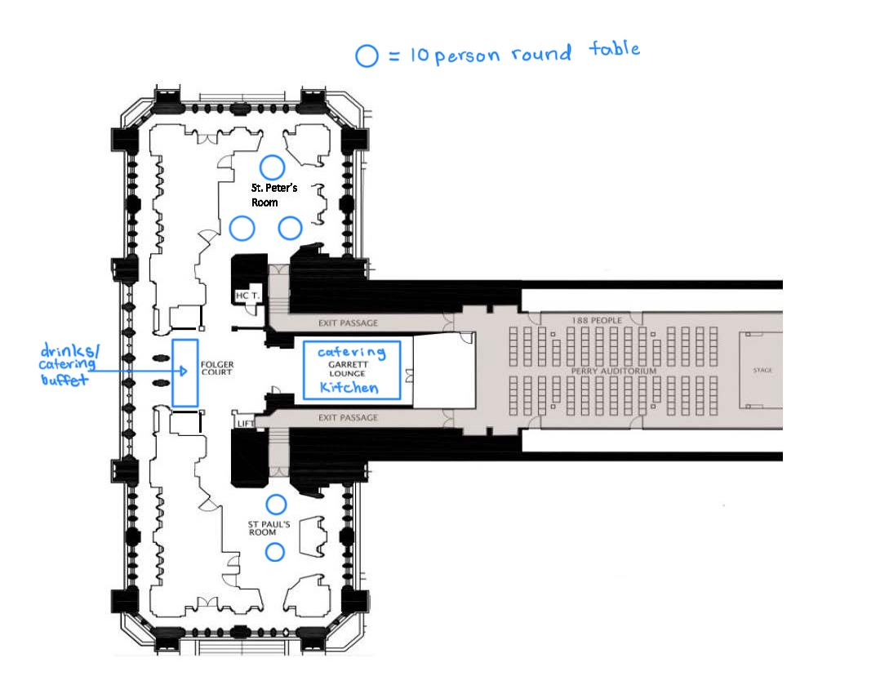

Nave (cocktail reception):
