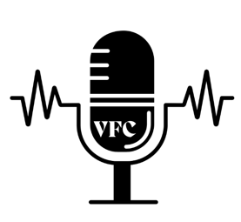

1710 Roy Acuff Pl

Nashville, TN 37203

(615) 256-3354

MEDIA ADVISORY

MEDIA CONTACT:

Natalie Gillum, Vice President

(615) 463-7596 | gillumvfc@gmail.com FOR IMMEDIATE RELEASE
VFC Hosts First Annual Music Industry Fair Pay Symposium

NASHVILLE, TN, February 6, 2025– Voices for Creators (VFC) is set to host first annual Music Industry Fair Pay Symposium, bringing songwriters, producers, composers and industry professionals together to discuss fair royalty compensation, copyright and policy efforts for the industry. The symposium will include panels, a keynote speaker and networking opportunities in and outside of VFC.

Who: Keynote: Mitch Glazier—RIAA CEO
Panelists: Taylor Swift—VFC CEO
Claire Cottrill—Singer/Songwriter
Ken Doroshow—Entertainment Lawyer
John Simson—Industry Veteran
Tom Clees—RIAA VP of Federal Policy
Professor. Linda Bloss-Baum—Director of Business and Entertainment program at American University

What: A music industry symposium on royalty compensation, copyright and lobbying efforts. Panels will offer professional discussions on these issues and what they mean for songwriters earning a fair wage.

When: February 20, 2025
10 A.M. – 8 P.M.

Where: Music City Center
201 Rep. John Lewis Way S
Nashville, TN 37203

Why: The Music Industry Fair Pay Symposium will work to address songwriters’ concerns over earning a livable income, especially in the age of AI. With heightened industry awareness of AI and royalty concerns, as well as growing tensions on the outcomes of potential future legislation, this event will bridge the crucial gap between industry knowledge and a collective path forward as an industry.

Voices for Creators is a non-profit organization committed to advocating for the rights, recognition, and fair compensation of songwriters, composers, and music producers. VFC empowers songwriters by offering educational workshops and resources, working closely with policymakers for reforms in favor of creators, and providing networking opportunities for a more empowered community of creatives. Learn more about VFC at voicesforcreators.com.

###

