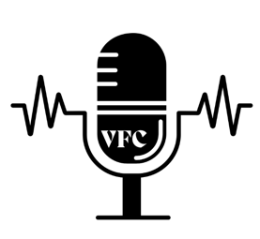

1710 Roy Acuff Pl

Nashville, TN 37203

(615) 256-3354

FOR IMMEDIATE RELEASE

MEDIA CONTACT:

Natalie Gillum, Vice President

(615) 463-7596 | gillumvfc@gmail.com
VFC Hosts Successful First Annual Symposium on Artist Rights and Equal Pay

NASHVILLE, TN, FEBRUARY 21, 2025– Voices for Creators (VFC) hosted their successful first annual Fair Pay Symposium on February 20, 2025. VFC hosted over 500 songwriters, producers, composers and industry professionals to discuss fair royalty compensation, copyright and policy efforts for the industry. The event was held at Music City Center and included a keynote speech, panel discussions and networking opportunities for attendees.

“This symposium was successful and allowed us to facilitate discussions on issues of fair pay and recognition for songwriters,” said Taylor Swift, VFC Executive Officer. “This annual event is an essential step in connecting our organization with the broader industry and letting potential members know of our services.”

The symposium’s keynote speaker, Mitch Glazier, highlighted the collective call for legislation to protect songwriters’ rights. Various panel discussions touched on issues such as royalty reform, copyright and IP as well as the challenges of being creative in the fast-paced music industry.

Workshops on negotiating contracts and streaming legalities were also offered to attendees. Event attendee Lila O'Kane noted, “The educational workshops were more than I could ask for and now I feel equipped with essential knowledge to advocate for myself in this industry.”

VFC announced new initiatives alongside their symposium. The mentorship program was announced at the event. This program allows for songwriters to be connected and paired with one another through their time at VFC. This mentorship will foster community and reliability for VFC members.

Voices for Creators is a non-profit organization committed to advocating for the rights, recognition, and fair compensation of songwriters, composers, and music producers. VFC empowers songwriters by offering educational workshops and resources, working closely with policymakers for reforms in favor of creators, and providing networking opportunities for a more empowered community of creatives. Learn more about VFC at voicesforcreators.com.

###

